## 

## PROJECT – 2

**Project Name :** Bootstrap and HTML Calculator

**Task :** Create a Calculator using HTML and Bootstrap

## 

## Contents

* ABSTRACT
* OBJECTIVE
* INTRODUCTION
* METHODOLOGY
* CODE
* RESULT & OUTPUT
* CONCLUSION

## ABSTRACT

This project presents an calculator web application developed using HTML, CSS, JS, and Bootstrap technologies. The calculator provides a user-friendly interface for performing basic arithmetic calculations conveniently and efficiently within a web browser. The core components of this web application are HTML , CSS , JS and BOOSTSTRAP . The key features of the calculator application includes Support for basic arithmetic operations, real-time display of input and calculated results , clear and intuitive user interface with visual feedback for button clicks.

**OBJECTIVE**

The objective of this project is to create a feature calculator web application that leverages HTML, CSS, JavaScript (JS), and Bootstrap technologies. The application aims to provide users with a versatile, intuitive, and visually appealing tool for performing various arithmetic calculations seamlessly within a web browser. The specific objective includes User-Friendly Interface , Interactive functionality ,Arithmetic Operations , real-Time Display , Bootstrap Integration , Error Handling , clear and concise code , Testing and validation . This project is to create an accessible, visually appealing, and feature-rich calculator web application using HTML, CSS, JavaScript, and Bootstrap. This application will serve as a valuable tool for individuals needing a versatile and user-friendly calculator solution for both personal and professional use.

**INTRODUCTION**

Web development refers to the process of creating and maintaining websites and web applications for the internet or an intranet. It involves a combination of various skills, technologies, and methodologies to design, develop, and deploy functional and interactive web solutions. The web development is categorized as front-end development , back – end development and full-stack development . A calculator is a device or software application designed to perform mathematical calculations quickly and accurately. Calculators come in various forms, from simple handheld devices to complex computer software. They are widely used in a variety of fields, including mathematics, science, engineering, finance, and everyday life. The key aspects of calculator include Functionality , User Interface , Accuracy , Precision , Educational use . This calculator is also of many types that are Basic calculators , Scientific calculators , Graphing calculators , Financial calculators , Programmable calculators , Printing calculators and so on. This calculator web application is built by using the front-end technologies, they are HTML , CSS , JS(Javascript) , BOOTSTRAP . These technologies became the most used one sin our daily life. With the help of these we built websites and we use daily in our life. The code is written to these technologies in a tool called Virtual Studio Code(VS code) and executed.

**HTML (Hyper Text Markup Language) :** HTML (Hypertext Markup Language) is the standard markup language used to create web pages and structure their content. It consists of a set of tags and elements that define the various components of a web page, such as headings, paragraphs, links, images, forms, and more. HTML plays a fundamental role in web development and is used in conjunction with CSS (Cascading Style Sheets) and JavaScript to create visually appealing, interactive, and responsive websites. It provides the structure and semantics needed to organize and present information on the internet, making it accessible to both humans and web browsers. HTML is one of the web development technology that is being used by all the people all over the world.

**CSS (Cascading Style Sheet) :** CSS (Cascading Style Sheets) is a language used for describing the presentation and styling of web documents written in HTML. It allows web developers to control the layout, appearance, and design of web pages, ensuring a consistent and visually appealing user experience across different devices and screen sizes. CSS achieves this by defining rules that specify how HTML elements should be displayed, including attributes like colors, fonts, spacing, positioning, and more. CSS is an essential part of modern web development, enabling the separation of content (HTML) from presentation (CSS), making websites easier to maintain, style, and adapt for various platforms and devices. It also plays a crucial role in enhancing user accessibility and optimizing page loading times.

**JS (Javascript) :** JavaScript is a versatile and widely-used programming language primarily used for adding interactivity and dynamic behavior to web pages. It allows developers to create responsive and feature-rich web applications by manipulating the content and behavior of websites in real-time within a user's web browser. JavaScript is an essential part of front-end web development, enabling actions like form validation, animations, real-time updates, and more. It can also be used in the back-end (Node.js) to build server-side applications. JavaScript is supported by all major web browsersand has a large ecosystem of libraries and frameworks, making it a powerful tool for creating modern web applications.

**JQuery :** jQuery is a fast, lightweight, and widely-used JavaScript library that simplifies and enhances web development tasks. It provides a set of powerful and easy-to-use functions and methods to simplify tasks such as HTML document traversal, event handling, animation, and AJAX interactions. jQuery is known for its cross-browser compatibility, making it a valuable tool for web developers to create interactive and dynamic web applications efficiently. It has significantly contributed to the simplification of JavaScript coding and is widely adopted in web development for its ability to streamline and standardize the coding process.

**BOOTSTRAP :** Bootstrap is a popular open-source front-end framework for web development that simplifies the process of designing and building responsive and visually appealing websites and web applications. Developed by Twitter, Bootstrap provides a collection of pre-designed HTML, CSS, and JavaScript components, such as navigation bars, buttons, forms, modals, and more. These components can be easily customized and integrated into web projects, saving developers time and effort. The features of bootstrap include Responsive design , Customization , Accessibility , Cross browser compatibility and Community and Ecosystem. Bootstrap simplifies front-end development by providing a well-documented and consistent set of tools and components, making it a valuable resource for both beginners and experienced web developers.

**VS code :** Visual Studio Code (VS Code) is a free, open-source code editor developed by Microsoft. It is widely regarded as one of the most popular and versatile code editors available today. Visual Studio Code is a Code editor , Cross-platforms , Extensible , Integrated terminal , Git Integration , Task Runner , Customization , Active Community and it also has Integrated development(IDE) features .Visual Studio Code is a highly customizable, cross-platform code editor with a vast ecosystem of extensions that can turn it into a powerful integrated development environment (IDE). Its versatility, user-friendly interface, and extensive feature set have made it a top choice for developers across different programming languages and industries.

**METHODOLOGY**

In the process of creating this calculator application , many steps have been involved. We will clearly see the steps now :

1. **Setting up the Tool :** the first step involved in the creation of this calculator application is deciding the tool and preparing the tool for usage. I used virtual studio code shortly known as VS code.
2. **Setting up XAMPP :**

* XAMPP is a free and open-source cross-platform web server solution stack package that consists mainly of the Apache HTTP Server, MariaDB database (MySQL replacement), and interpreters for scripts written in the PHP and Perl programming languages.
* Installation of XAMPP from the google in the apachefriends.org website and install it.

1. **Creating required files for the website :** A file is created in the XAMPP folder , that file consists of Bootstrap, CSS , JS and HTML.
2. **Creating the HTML page :** Creating a html page in the VS code.
3. **Associating the CSS and JS :**

* Downloading the Bootstrap CSS and JS files from the Bootstrap official website and add file with the html page .
* Linking the CSS file and Bootstrap icons link which is copied from the Bootstrap website in the head section of the html page.
* Then, linking the JQuery and popper.js link which is copied from the JQuery website in the body section with the script tag of the html page.

1. **Designing the webpage :** writing the code using HTML , CSS.
2. **Execution of the code :** Executing the written code in the html page and checking whether we got the required result or not.

**CODE**

<!DOCTYPE html>

<html lang="en">

<head>

<meta charset="UTF-8">

<meta name="viewport" content="width=device-width, initial-scale=1.0">

<title>Calculator</title>

<link href="vendor/Bootstrap/css/bootstrap.css" rel="stylesheet">

<link href="https://cdn.jsdelivr.net/npm/bootstrap@5.3.2/dist/css/bootstrap.min.css" rel="stylesheet"

integrity="sha384-T3c6CoIi6uLrA9TneNEoa7RxnatzjcDSCmG1MXxSR1GAsXEV/Dwwykc2MPK8M2HN"

crossorigin="anonymous">

<style>

.row>button {

width: 100px;

height: 100px;

background-color: rgba(67, 65, 63, 0.484);

box-shadow: 0 5px #666;

font-weight: bold;

border-color: black;

margin: 1px;

font-family: Arial, Helvetica, sans-serif

}

.display>input {

font-weight: bold;

padding-top: 10px;

text-align: center;

font-size: larger;

font-family: Arial, Helvetica, sans-serif;

}

.d-flex justify-content-center {

padding-top: 20px;

float: none;

}

</style>

</head>

<body style="background-color:lemonchiffon;">

<h1 class="d-flex justify-content-center">Calculator</h1>

<div class="respon">

</div><br /><br />

<div class="d-flex justify-content-center">

<div class="container">

<div class="display; d-flex justify-content-center">

<input type="text" name="" id="screen" placeholder="0" readonly>

</div>

<div class="btns" style="padding: 10px; padding-bottom: 10px;">

<div class="d-flex justify-content-center">

<div class="row">

<button type=button class="backspace">CE</button>

<button type=button class="AC">AC</button>

</div>

</div>

<div class="d-flex justify-content-center">

<div class="row">

<button type=button id="seven" class="btn">7</button>

<button type=button id="eight" class="btn">8</button>

<button type=button id="nine" class="btn">9</button>

<button type=button id="divide" class="btn">/</button>

</div>

</div>

<div class="d-flex justify-content-center">

<div class="row">

<button type=button id="four" class="btn">4</button>

<button type=button id="five" class="btn">5</button>

<button type=button id="six" class="btn">6</button>

<button type=button id="multi" class="btn">x</button>

</div>

</div>

<div class="d-flex justify-content-center">

<div class="row">

<button type=button id="one" class="btn">1</button>

<button type=button id="two" class="btn">2</button>

<button type=button id="three" class="btn">3</button>

<button type=button id="subs" class="btn">-</button>

</div>

</div>

<div class="d-flex justify-content-center">

<div class="row">

<button type=button id="zero" class="btn">0</button>

<button type=button id="dot" class="btn dot">.</button>

<button type=button id="equal" class="result">=</button>

<button type=button id="add" class="btn">+</button>

</div>

</div>

</div>

</div>

</div>

<script src="https://ajax.googleapis.com/ajax/libs/jquery/3.7.1/jquery.min.js"></script>

<script src="https://cdn.jsdelivr.net/npm/@popperjs/core@2.11.8/dist/umd/popper.min.js"

integrity="sha384-I7E8VVD/ismYTF4hNIPjVp/Zjvgyol6VFvRkX/vR+Vc4jQkC+hVqc2pM8ODewa9r"

crossorigin="anonymous"></script>

<script src="vendor/Bootstrap/js/bootstrap.js"></script>

<script>

let screen = document.querySelector('#screen');

let btn = document.querySelectorAll('.btn');

let result = document.querySelector('.result');

let acBtn = document.querySelector('.AC')

let backspaceBtn = document.querySelector('.backspace')

for (i of btn){

i.addEventListener('click', (e)=>{

btnText = e.target.innerText;

if(btnText == 'x'){

btnText = '*';

}

if(btnText == '÷'){

btnText = '/';

}

screen.value += btnText;

console.log(btnText);

})

}

result.addEventListener('click', ()=>{

screen.value = eval(screen.value);

})

acBtn.addEventListener('click', ()=>{

screen.value = '';

})

backspaceBtn.addEventListener('click', ()=>{

screen.value = screen.value.substr(0, screen.value.length-1);

})

</script>

</body>

</html>

**RESULT & OUTPUT**

**1)**

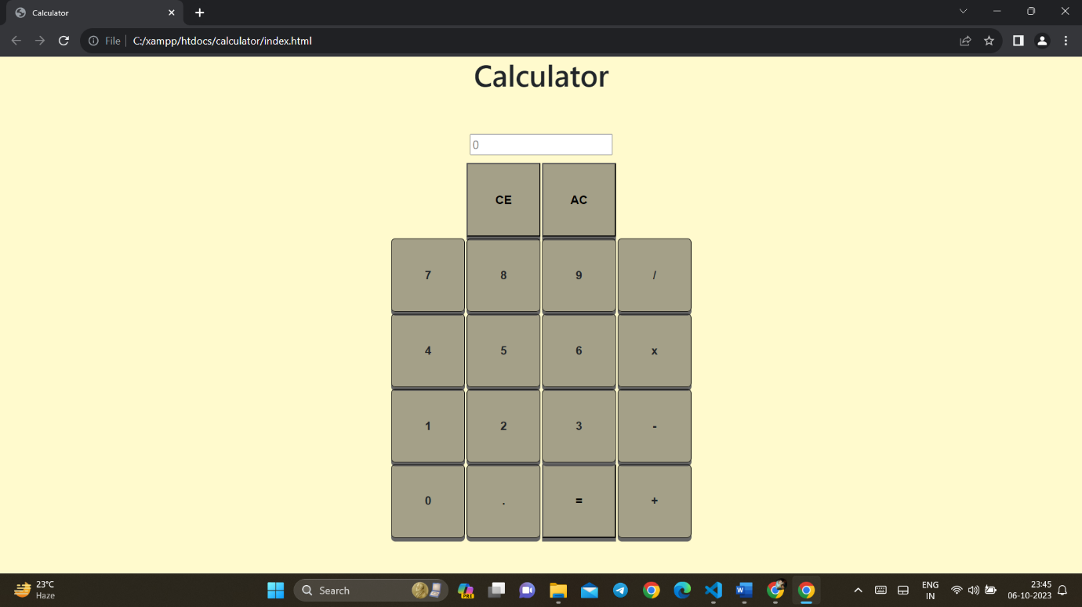

**2)**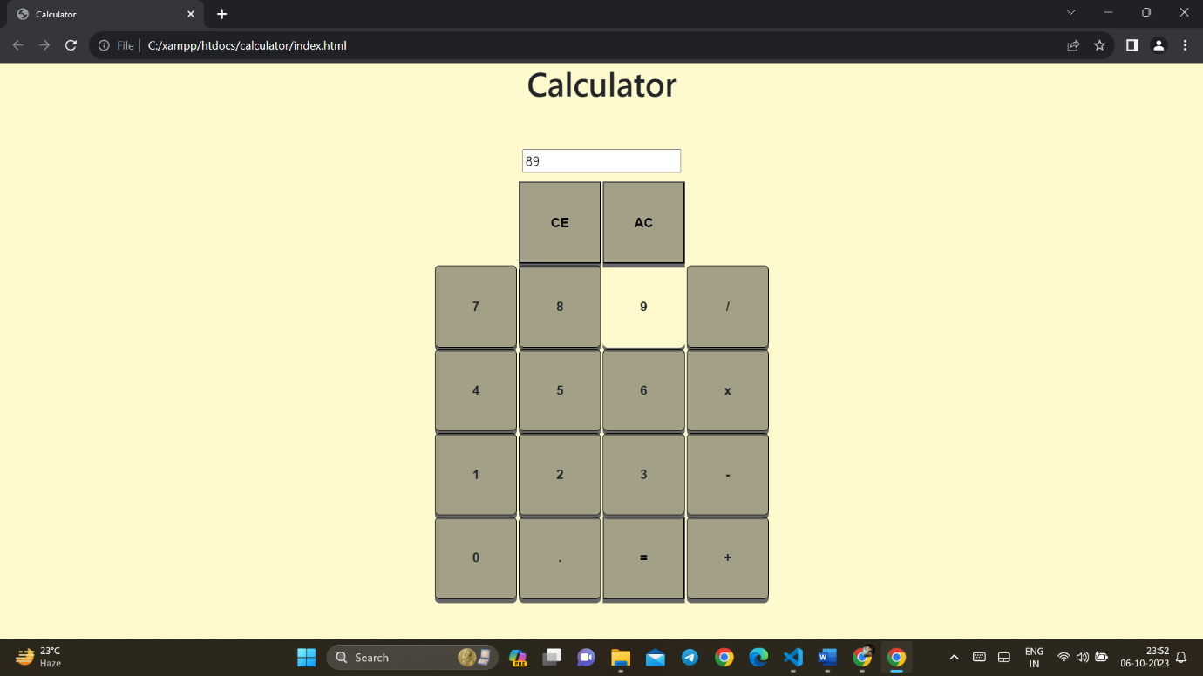

**3)**

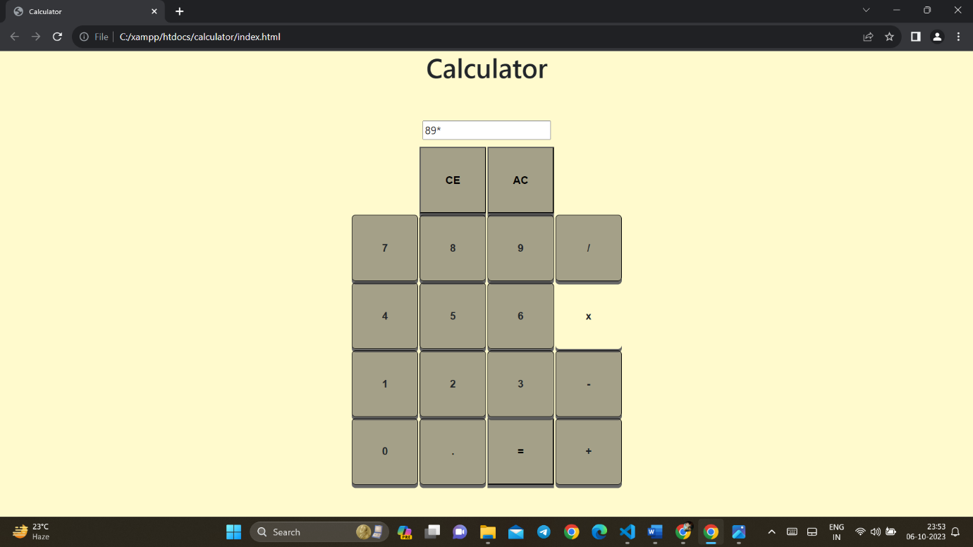

**4)**

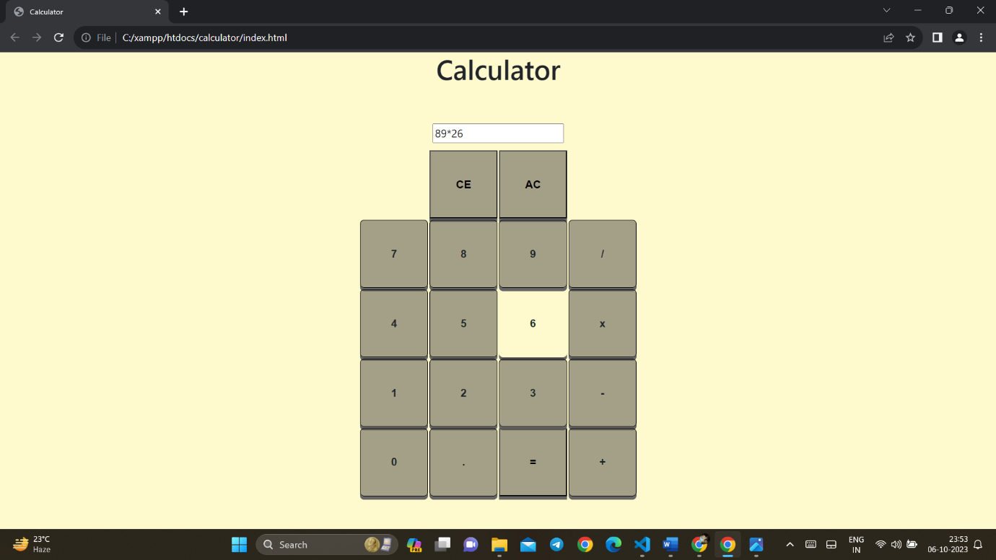

**5)**

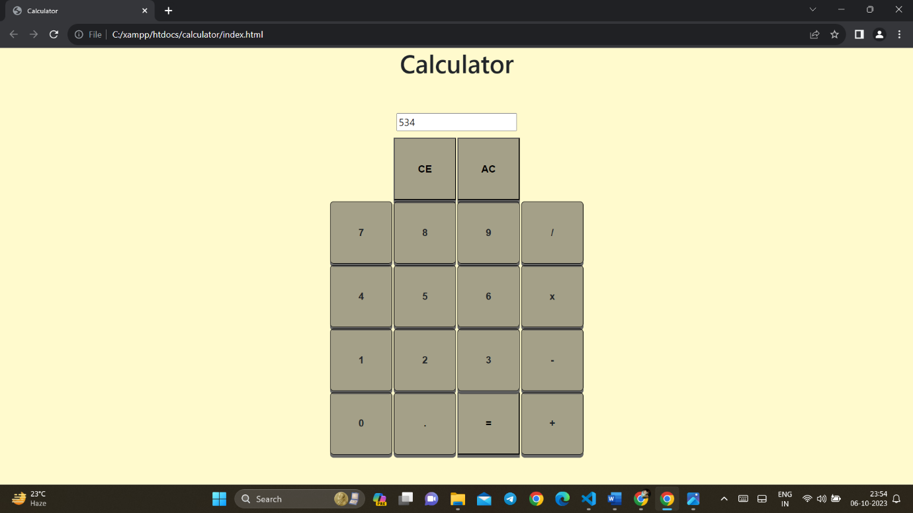

**6)**

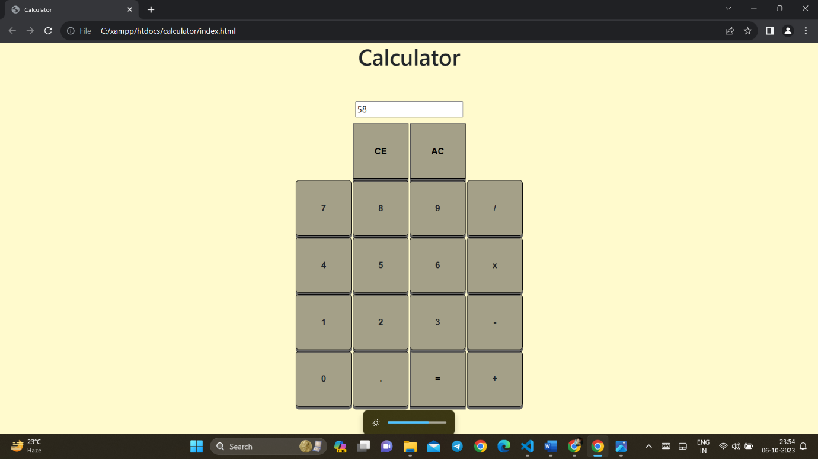

**CONCLUSION**

In conclusion, the development of a calculator using HTML, CSS,jQuery, and Bootstrap results in a versatile and user-friendly web application. This project combines the power of these technologies to create a calculator . It gives the output with some of the key features which are Accessibility , User Experience , Interactivity , Functionality , Cross-browser compatibility and Education and learning. The calculator developed using HTML, CSS, jQuery, and Bootstrap exemplifies the power of these technologies when combined to create a functional and visually appealing web application. It showcases the importance of accessible design, responsive layouts, interactivity, and error handling in web development, making it a valuable project for both learners and developers looking to create effective and user-friendly web applications.